# Introduction

Hello, here in this project I will attempt to make a be Unity project in 3D, as of currently I know completely nothing on how to use the 3D version, and so, will trying to implement new ideas as time goes. Since I am a complete beginner at 3D Unity, I will share the process of following tutorials as well as the code implements and my thought process as I go along creating the game.

As for the actual game itself I have decided to be perhaps some sort of shooter fps as I have played many fps shooters such as Valorant and Counter Strike and would like to create one for myself if is possible that is. This would probably include something like some bots to shoot at, recoil of a gun, and a fairly decent map to play around but this will be decided later.

Before designing the game and what to implement into it I will have to first accustom myself and learn to how to use certain programs to actually make the game itself, then I will move onto actually making the game.

So, I hope you will enjoy reading through the process of making this game from an complete amateur game developer, I hope you enjoy!

# 

## Installing Necessary Software

First to understand how to model a game environment I watched a full tutorial from Adam Zainudin (Zainudin, 2024) on the features found in the package manager of Unity – he posts some very useful simple tutorials on using ProBuilder so I’d recommend to check him out if you are beginning to learn Unity modelling.

After some further research on developing an environment for a game, the most popular package overall used was called ProBuilder – this seemed to be commonly used amongst all the unity tutorials I viewed and researched when designing games in Unity 3D so I decided to use it.

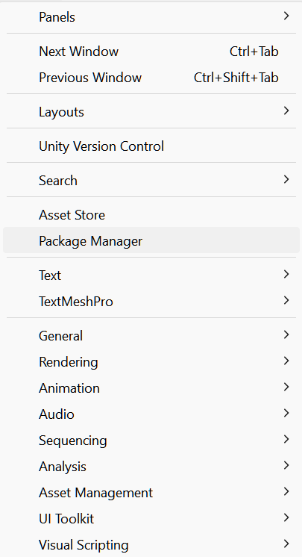

So to begin, I installed ProBuilder from the manager then looked at all the features that could be used before continuing watching the tutorial to comprehend how they worked.

I learned concepts on using icon mode and text mode depending on my preference as well as why lighting is important .  
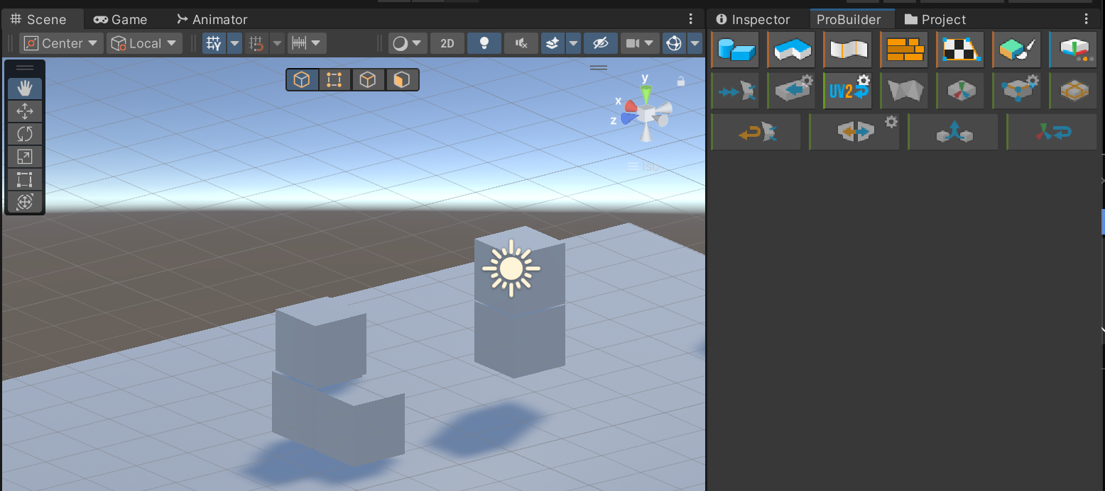

Also by using ProBuilders dimension overlay, object dimension would be able to be seen – a useful way allowing to see the scale of objects. Along the way here I learned some simple logic – Unity Cube are scaled by 1m by 1m.

An additional package was called ProGrids I did have issues trying to find this package in the package manager but it wasn’t there. Well after some further searching online the Unity Forum, since these tutorials using ProGrids was from a few years ago it didn’t seem to receive anymore updates and is no longer in the package manager installer so I had to install it via link:

Next from the tutorials I learnt using ProGrids – learning important concepts such as grid snapping for x, y and z of objects

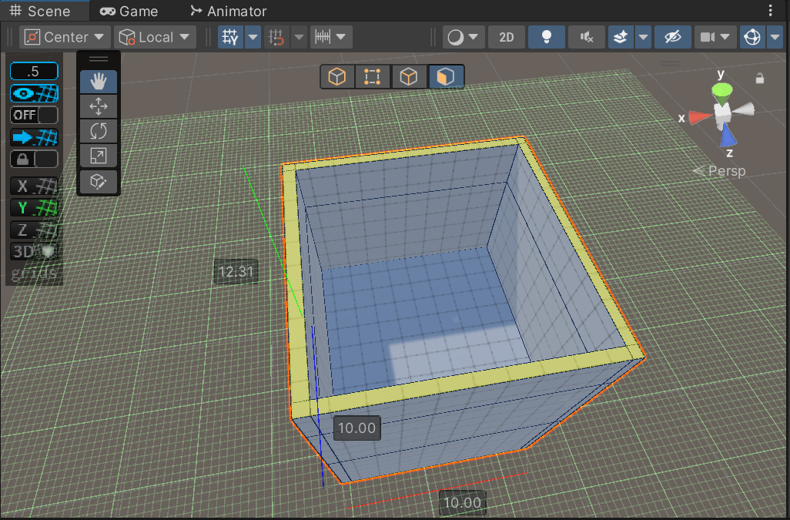

This ended up taking a while to produce due to me forgetting to using shift when highlighting the corners so that only the sides of the build would change rather than the whole object, at least I have learnt that now. Now that I have produced some sort of layout of where the game will happen, its time design each room.

